Oldham – An Analysis of the Electoral Socio-Demographics

By

Cllr Ged Mirfin

A Research Paper

Oldham’s Working Class Voters are a constituency in search of representation. At first reading such a statement may seem odd. Is the Labour Party not the natural political party of the working class? Oldham is the UK’s most Working Class Constituency not only because of the presence of significant cohorts of particular socio-demographic groups but also Oldham is also the largest Conurbation in Greater Manchester. Labour’s Electoral predominance, however, in both Parliamentary Elections and in the Wards which make up the Constituency in Local Council Elections rather than acting to benefit the Working Class has had the adverse effect significantly marginalizing and actually diminishing their influence with the result that their interests have become increasingly peripheral. Consequently Oldham & Royton has become a bellweather constituency for a variety of forms of protest Vote in response to different national trends and local events. In the early to mid 2000s there was a dramatic increase in support for the Liberal Democrats largely in response to the failures of the Blair Governments and the Gulf War. In the early to mid 2000s there was a dramatic increase in support particularly in middle class wards for the BNP in direct response to the Oldham Riots in 2001. The BNP became deeply embedded as a Political Party in Oldham as it made the constituency its North West base achieving high levels of support in the Local Council Elections up to 2008 and standing in the General Election the last time in 2010. The latest protest Vote is UKIP who had an electoral presence in their original incarnation standing in the Local Council Elections as long ago as 2004. UKIP however have achieved significant electoral impact in 2014 and 2015 as both the subject of an EU Referendum has come into national focus and UKIP’s influence on the national political scene increased exponentially. Interspersed with this have been large Electoral Votes for Independent Candidates standing on a range of local based issues and also rather surprisingly given the level of deprivation across the Constituency – the Greens. This Paper will seek to explore the more recent electoral impact of UKIP within the Constituency offering explanations which draw on the Blue Labour literature on the patriotic working class and the increasing ambivalence to the working class interests demonstrated by Oldham Council’s attempt to turn itself into a self-styled co-operative Council.
Oldham and Royton – Britain’s Most Working Class Constituency
Since it was created in 1997 the Oldham and Royton consituency has only had one MP: Michael Meacher. It's not so much that an MP defines a constituency but more that a constituency defines an MP. What I mean is that some MPs are elected and then re-elected (in some cases repeatedly) but their prospects of bringing about change for the better are minimal if not impossible. In Oldham's case it is arguable that 21 years of Labour representation has been symptomatic of the managed decline of this once prosperous Northern mill town located on the outer periphery increasingly both economically and mentally on the outskirts of Greater Manchester. Oldham is the UK's 3rd largest conurbation.The average gross weekly income in the borough is £297; not only is this below the national average but it is the lowest of Greater Manchester's ten boroughs. Also despite improvements in school and college outcomes, the proportion of residents with degree-level qualifications (18.6%) has fallen further behind national rates (27.4%). The rates of people working in the areas of finance and property are below the national averages whilst the proportion of people working in retail and wholesale was above the national average of 16.7%, and much higher than the national average of 14.8% for people working in manufacturing.
This raises the much more fundamental question of just what it is actually possible for the sitting Member of Parliament to achieve? I have heard a number of MPs state that if they left their constituency in no worse a condition when they stopped being MP than when they had started then they would have done a good job. I must admit I feel both a little angered and disenchanted at such a notion. If you can't make things better why set out on the political journey of representation in the first place? Surely politics is ultimately about trying to improve people's lives? I have come to realise over the years that there are large social and economic forces at work which engulf and are beyond the ability of one individual to control. If that is the case and the MP represents an already prosperous constituency - all fine and well. If on the other hand the fortunes of a constituency are worsening rather than improving to what extent has voting for the sitting Member of Parliament become simply habit forming and difficult to break out of because it is perceived that there are a lack of alternatives? Indeed, have Voters become apathetic to the possibility of valid alternatives because they accept that it is impossible to break out of the cycle of gradual and inevitable decline or resigned to their fate when confronted by a situation of suboptimal homeostasis electing the same politial party year after year ad nauseam? It is a both a pessimistic and demoralising outcome to think that it is impossible to break out of this feedback loop.
The electoral statistics for the Oldham and Royton Constituency are extremely revealing. Because of the rise of the UKIP Vote and the collapse of the Liberal Democrats, 2015 was tthe exception rather than the rule. The period 1997 to 2010 shows the gradual long-term and inexorable decline in the Labour Vote in a constituency where Turn-Out is consistently well below the National Average.
As we can see from the General Election results to date between 1997 and 2010 the Labour Vote declined by 7,391 Votes or 8.4% - an Average of 1,848 Votes or 2.1% per Election. Based on a straight line trend in 2015 Labour's Vote could have been expected to have fallen to 17,655 or 44.1%. In the same period Labour's majority fell by 6,839 Votes or 1,710 Votes per Election. Again based on a straight line trend in 2015 Labour's majority could have been expected to have fallen to 7,652.
In the By-Election it is expected that Labour's Vote will fall further. Labour Voters are now questioining the pacifist stance of its Leader Jeremy Corbyn and the lack of a robust response to ISIS and a failure to support the renewal of Trident and maintain an Independent Nuclear Deterrent in the UK.
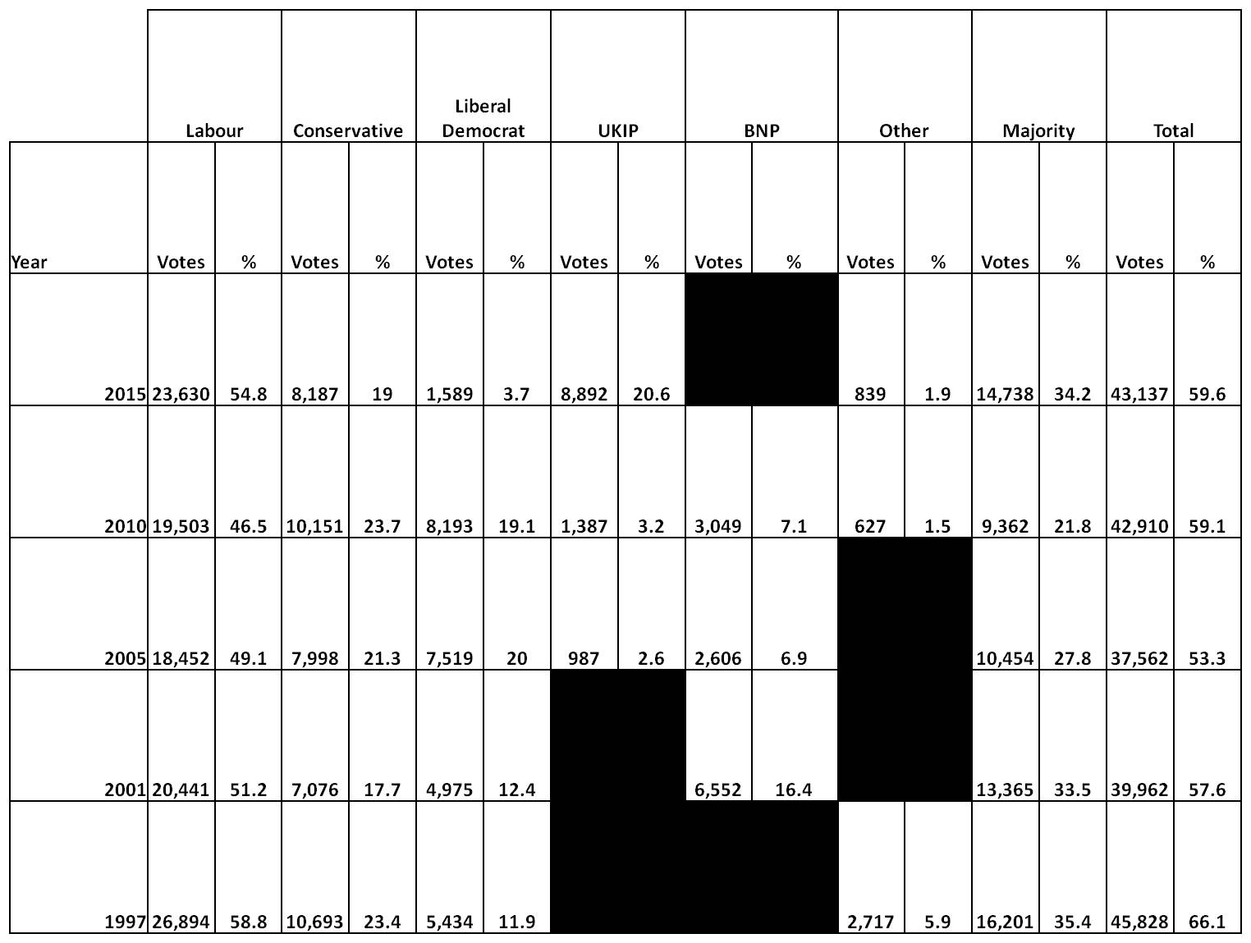
In that sense the 2015 General Election in the Oldham & Royston constituency was the exception rather than the rule.

Both the Labour Vote 23,360 and the Labour Majority 14,738 were artificial. The Labour Vote had increased by 4,127 and it’s Majority by 5,376 Votes. This was down to 2 principal factors.The first was the rise in the UKIP Vote. UKIP received an additional 7,505 Votes. 3,049 Votes came from collapsing BNP support in a constituency where there is a strong base of support for Extreme Right Political Parties and Groupings (BNP, National Front, England First, the English Defence League). Indeed Nick Griffin himself - the former leader of the BNP has stood both for Parliament and in the Local Council Elections - losing on both occasions. A further 1,964 Votes were lost by the Conservatives to UKIP principally in working class areas. The remaining 2,492 Votes came from Labour Voters.
The second and much more important factor for Labour was the fact that 6,600 left leaning Liberal Democrat Voters switched their allegiance virtually en masse to Labour giving it an increase in majority of 4,127, one suspects in protest by self-styled Protest Voters in protest in turn against the Liberal Democrat presence in the coalition. Of course there is more too it than that which is revealed by the Electoral Returns from the Local Council Elections in the Wards which make up the Oldham and Royton constituency. One thing is clear and that is with the election of a much more left wing radical leader in Tim Farron Labour cannot continue to rely on the support of former Liberal Denocrats. It is unlikely that all will return to the Liberal Democrat, some may prefer voting Green as a more palatable alternative to what they see as a Marxist tinged Labour Party led by Jeremy Corbyn but if the Liberals can recapture c2-3,000 Votes it can make potentially for a very interesting By-Election.
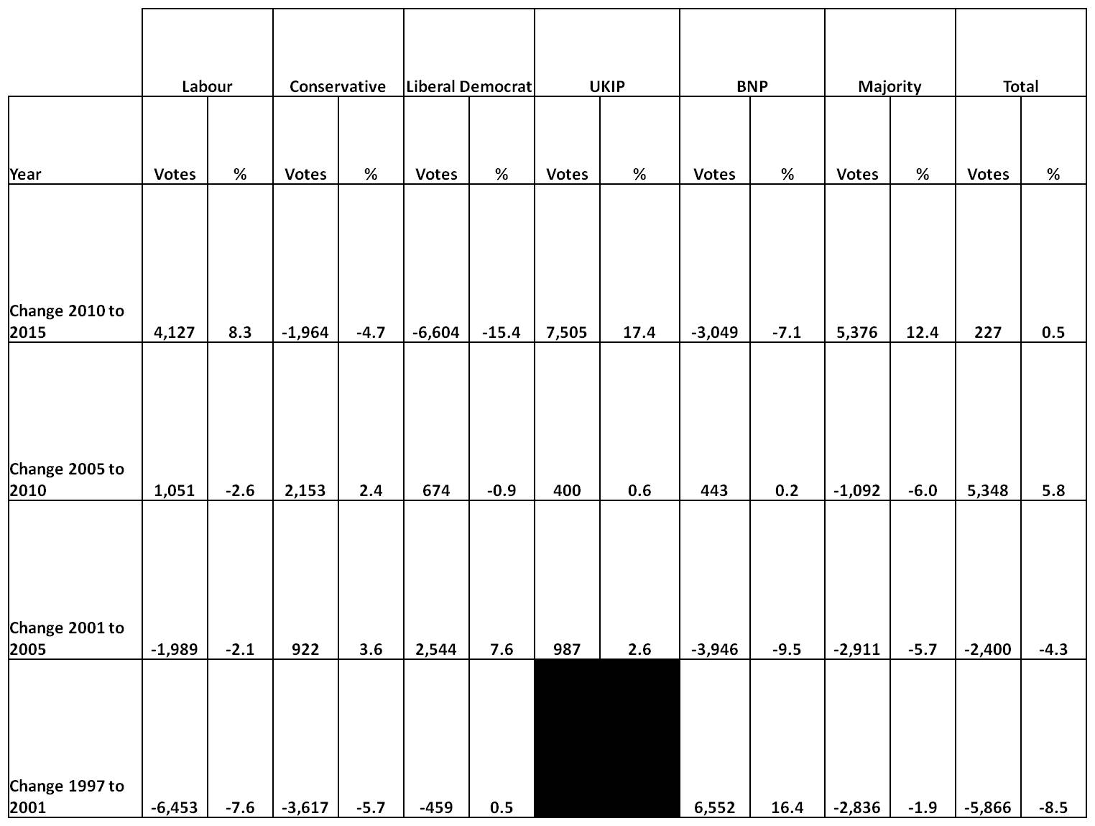
However much the current Labour controlled Council is pursuing an Activist Community-based style of Politics - the fact is that 1 in 5 Voters in Oldham is not buying into this. Indeed the fact that it is actively rejecting this brand of Activist Community Politics which underpins the notion of a Co-operative Council is a cause for concern. Voters in Oldham are no longer protesting by Voting Liberal Democrat - they are doing so by Voting for Parties of the Populist Right.
Oldham and Royton – a False Safe Seat
Oldham and Royton is what I have dubbed a False Safe Seat. What this means is that more Voters Vote for Parties other than the one that actualy wins and with the exception of 2015 have done so since 2005. Unfortunately that opposition is permanently split between the Conservatives, the Liberal Democrats and whatever flavour of Populist Political Party on the Extreme Right that is flavour of the month. The problem that creates is that this artificially enhances the position of the dominant Political Party The result is that Working Class Voters (and increasingly frequently led by Middle Class Voters) are turning to highly reactive Populist forms of Politics on the Right in Protest.
In a highly reactive politics of protest which is both populist and right wing there is a rejection of the existing political consensus which is blamed for the failure of the political system. Right-wing populist parties or the radical right are generally known for their opposition to immigration, mostly from the Islamic world, and the European Union, as well as their increasing support for the welfare state and a "more lavish, but also more restrictive, domestic social spending" scheme (sometimes called "welfare chauvinism". This is the notion that welfare benefits should be restricted to certain groups, particularly to the natives of a country as opposed to immigrants. It is used as a manifesto, mainly by radical right-wing populist parties and describes the connection between the problems of the welfare state and immigration. According to welfare chauvinists, the safety net of the welfare state are for those who they believe belong in the community - those who are a part of society's welfare and the country's prosperity; community builders, i.e. "the people"; the ordinary honest working man – “the people’s army” in UKIP parlance. Their success depends on their ability to mobilize resentment and protest. It has become commonplace to attribute the growing appeal of radical right-wing populism to the recent explosion of hostility towards immigrants in much of Western Europe. Not only the sheer numbers but also the changing composition of refugee and immigrant populations has contributed to the xenophobic upswell.
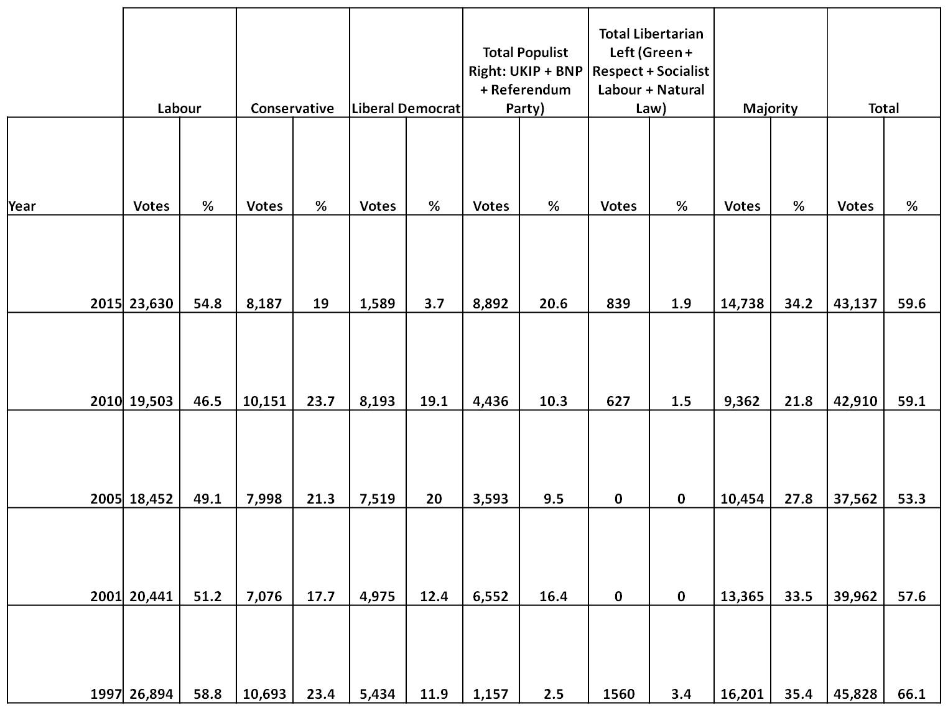
The Local Election Results in the Wards covering the constituency: Chadderton Central, Chadderton Northm Chadderton South, Coldhurst, Hollinwood, Medlock Vale, Royton North, Royton South and Werneth are particularly revealing for a number of reasons. The first and perhaps most surprising is that there has actually been a noticeable decline in the Labour Vote in Local Council Elections since Jim McMahon took over as Leader of the Council from 65.72% to 52.86% - a decline of 12.34% or 18.78%.
However, Oldham is a low-skilled low-wage economy with migrants competing for a large number of available jobs. Traditional Labour Voters will tell you that wages, public services, quality of and access to local schools, GP surgeries and social housing are all under pressure. Why aren't they doing better thay are asking in an increasingly vocal manner? Voting for UKIP in increasingly large numbers is only the most visible sign of their discontent.
It is the less visible sign of this discontent that is the most troublesome for Labour. The question is has the Labour Party become too middle class to appeal to the Working Class? According to the current Philosopher in Chief, of the Labour Party Maurice, now enobled in the House of Lords as Baron Glasman of Stoke Newington and of Stamford Hill in the London Borough of Hackney, Senior lecturer in Political Theory at London Metropolitan University the party has become too “middle class” – and blames this culture for UKIP’s current popularity. Glasman suggests that the loss of working class support is difficult to address particularly, “when the party is becoming, in many ways, very middle class”. For Glasman a large part of the problem stems from the fact that the Labour Party has been taken over by an increasingly detached liberal elite.
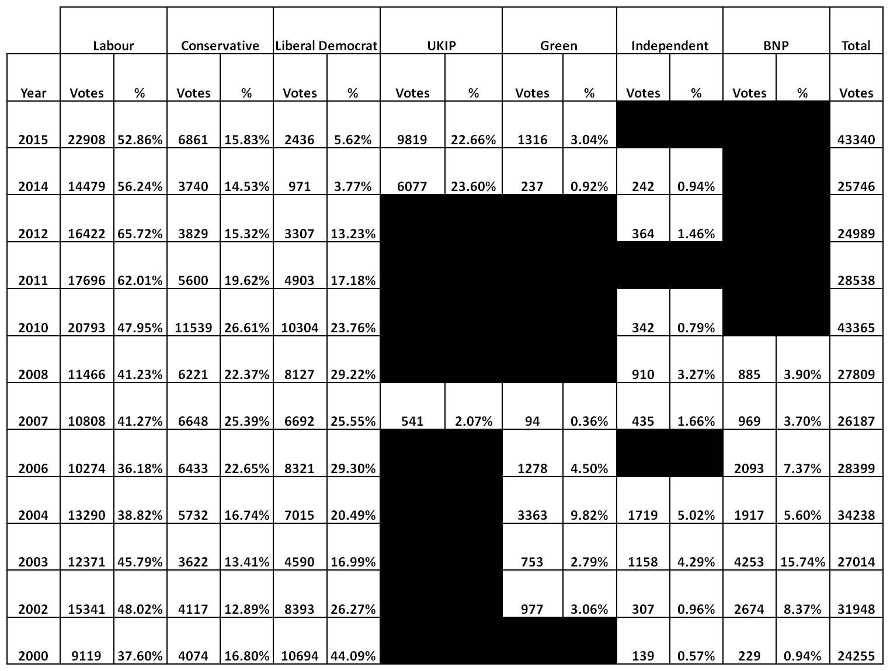
In an interview with the Financial Times recently, Glasman warned before the General Election that Labour was flirting with electoral disaster by being too “middle-class”. Labour is losing voters hand over fist to UKIP in its “heartlands”, he said. Labour voters who defected to UKIP may never return because the party is failing to address concerns on welfare and immigration. “That is the dilemma at the heart of the party’s strategy — is it possible to address these economic, political and cultural concerns when the party is becoming, in many ways, very middle-class?” The New Labour government, Glasman argues, became very sharply associated with what he dubs the liberal strand - a kind of strand which emphasized the importance of individual rights and entitlements and which tended, to be disdainful of the everyday practices of people as they lived their lives in different parts of the country - the very kind of politics that the Labour candidate, Jim McMahon, epitomises. So disillusioned had Glasman become that he expounded in one BBC Radio interview, “I don’t think that New Labour really like working-class people.”
For Glasman Labour is now so middle class it no longer appeals to working-class people. Glasman believes that by defining themselves as working class UKIP represent a major political threat to and has the potential to supplant the Labour Party if infact it is not already doing so. Glasman argues that the Labour middle-class vote held up [in 2010]. It was the working-class vote that died. “These are often people who are earning, who have jobs, but they don't see Labour as representing their interests," he says. According to Glasman many working class communities have a feeling of “dispossession and abandonment”. "There was possibly an assumption at first that [the rise of UKIP] would just work against the Tories," he said. "But there is a view that says that after the European and local elections are over, there could be a swing back to the Conservatives or UKIP voters. But will there be necessarily a swing back to Labour from the UKIP voters?"
Labour supporters can’t talk about immigration
One comment which Glasman made which was widely reported was that, “Working-class men can't really speak at Labour Party meetings about what causes them grief, concerns about their family, concerns about immigration, love of country, without being falsely stereotyped as sexist, racist, nationalist." It was the strongest recognition thus far by a Labour adviser of the gap between the Labour Party and the views and interests of many of its traditional supporters.The reality is that Labour is a more middle-class party now that it’s ever been. Partly this is a consequence of the middle class looking over their shoulder and asking themselves are they not working class after all? For some members of the middle class the Cost of Living Crisis that the Labour Party talks about resonate strongly with them – they have yet to feel the benefits of the Conservative’s Long-Term Economic Growth Plan as fully as some other parts of the middle classes. It is also the result of the hangover from Blair’s modernisation project - a project which is continuing in Oldham, particularly for middle class Public Sector Employees whose jobs are under threat in the next round of Budget Efficiencies. It is also because a key Labour electoral strategy is to reach out to disaffected Liberal Democrat Voters who are middle class to their core.
The fundamental conservatism of the Working Class
Glasman has goaded the Labour leadership for being too liberal and progressive in its sensibility. As a member of the Centre-Left who would theoretically like to engage with the working-class more fully he is all too aware of how terrified many middle class members of the Labour Party are of the impact that engagement would have on their own liberal sensitivities calling for the party to re-establish its connections with people across the country.Glasman argues that the Labour Party should embrace what he regards as the fundamental conservatism of the working class. These include the family, patriotism, faith and the work ethic. As such Blue Labour advocates, in Glasman's words, "a deeply conservative socialism". They argue that for a fundamentally conservative working class an ethics of community and solidarity implies a defence of traditional institutions and identities such as the family, patriotism and the nation, faith and the work ethic. What has become known as the Blue Labour approach is often summarised with the slogan; ‘faith, family and flag’. They also argue that defence of traditional working class community values and identities specifically implies by definition a defence of British ‘white working class’ traditions and identities. They argue that ‘mass immigration’ and ‘multiculturalism’ has been hugely destructive in terms of community cohesion and so must be resisted.
New Labour alienated the Working Classes
Blue Labourites contend that New Labour’s metropolitan liberalism alienated socially conservative working class communities (hence the colour blue). Moreover, this has significantly contributed to the established view that Britain’s parliamentary elite is out of touch, especially on issues such as EU immigration. Appealing to working-class votes is sometimes dismissed as a “core vote” strategy. Glasman has been pilloried for arguing that Labour should “involve those people who support the EDL within the party”. It is important to place such a remark fully in the context in which it was argued. What he is not arguing, as he has been accused by those on the left of the Labour Party, is that, ‘if we can’t beat the BNP, let’s become the BNP’! Instead what he is arguing is giving the working class more of a voice. He has pointedly argued that, "working-class men can't really speak at Labour party meetings about what causes them grief, concerns about their family, concerns about immigration, love of country, without being falsely stereotyped as sexist, racist, nationalist". This is an approach which appears fundamentally at odds with large parts of the leadership of the Labour Party. Such an approach has been described as ugly. The Labour leadership have a hard time admitting that the working class want much tighter controls on immigration. It is they that confront the reality on a daily basis in a deregulated fee market economy of competition for employment opportunities from immigrants that come from right across the EU and not just South East and East Central Europe. Pressures on housing, jobs and public services caused by an influx of migrants tend to be more keenly felt by working-class families. These voters are rarely racist. Their concern however is about security of employment, access to housing, quality of education and they see the metropolitan elite receiving all the positives from mass migration while they are only exposed to the downside. Working Class People neither resent nor show hostility to the new neighbours next door. They welcome them as fellow human beings. However they also say that it is their jobs, GP waiting times and council house applications which are affected and they resent being personally deprioritised. For them the Labour elite always find the top schools for their children. They find their way to the top restaurants. They live different lives to the voters whose support they need. But it is more than that. These voters are aspirational too. They want common sense and a fair deal.
Jon Cruddas: the Conservative Politics of Earning and Belonging
It is a view which has been echoed contraversially by Jon Cruddas, the Labour Party’s Policy Co-ordinator and MP for Dagenham and Rainham. Blue Labour, he argues, need to address the “loss of the working class that has economically disintegrated and culturally disintegrated” and create debates to tackle this otherwise there would be “no future with Labour”. For Cruddas, the fatal flaw of the Labour left was that it struggled to understand or to involve the people in whose name it wanted to act. If Labour moves away from bureaucratic, middle class radicalism, he believes, towards championing a more patriotic, English style of radicalism, which resonates with blue collar voters that would be of real concern to Tories.
Cruddas argues that Labour’s renewal and electoral victory is best rooted in a radical and conservative politics of earning and belonging. He has written that Labour’s traditions are conservative in valuing relationships, work, family and community. At the heart of the Labour interest has been a deep conservative instinct for the preservation of society and people’s mutual dependence. Cruddas’ form of socialism is essentially quite conservative, about protecting working-class neighbourhoods from the worst excesses of globalism. He dubs the importance of community engagement, continuity and a sense of place as “conservative radicalism.” He suggests that: “This politics is conservative, in that it values the continuity of the social goods which shape people's lives: home, family, relationships, good work, locality and communities of belonging."
At the same time Cruddas has sensed the insecurity at the heart of working class life and the subsequent disengagement from politics.He too believes there should be tighter regulation on immigration. He says: “When your community changes around you, it’s very uncomfortable. I think Labour should conserve things – families, relationships, communities.” According to Cruddas the Labour Party is the most Conservative Political Party in Britain because the notion of belonging to a community is a deeply Conservative idea. This assumes of course that the working class still support the Labour Party or that there is still a distinctive socio-demographic group which on can identify as being the working class. What is clear, and here I agree with Cruddas, is that there is an increasingly large group of Voters who wish to control the process of rapid political and economic change more effectively rather than simply being driven by it. Unfortunately for both the Conservative and Labour Parties it is UKIP with its message of thus far and no further that is becoming the prime beneficiaries of this group of working class voters. In a speech he gave in May this year which he’d delivered at the ACEVO Gathering of Social Leaders he said that,” UKIP is exploiting this mood in Labour’s English heartlands where traditional ways of life have been devastated. often in places still suffering from the industrial and social changes of the 1980s. Places like Oldham.
Revolt on the Right Thesis
In their book “Revolt on the Right: Explaining Support for the Radical Right in Britain” (2014) Robert Ford, Lecturer at the University of Manchester and Matthew Goodwin, Associate Professor at the University of Nottingham and Associate Fellow at Chatham House, point out that UKIP is now arguably Britain's most working-class party. Indeed when Labour was in Government under Tony Blair, and then Gordon Brown, UKIP picked up more support from Labour than from the Tories. Many UKIP supporters are former Labour voters who had steadily lost faith in the party over its long term of office, and who in the General Election of 2010, as floating Voters, switched to the Conservative Party under Cameron.
Oldham has a greater proportion of working-class people than the whole of England. In 1900 Oldham had the highest concentration of chip shops in the country, one for every 400 people. The problem for Labour therefore is that the Labour Candidate Jim McMahon hardly epitomises the left wing Corbyn agenda. He is instantly recogniseable and is name checked heavily by voters. This is unsurprising.The Council operates a "strong leader" cabinet model, under which the person elected to be the Leader of the Council personally holds all the executive decision making powers.I t a matter of discretion for the Leader whether he/she exercises those powers personally or delegates them. Generally decisions are delegated to individual cabinet members or to the councils Cabinet. Clearly however a brand of politics built on P.R. and the use of Social Media has the potential to turn off older cohots of the electorate who blame the Labour Government of Gordom Brown for the recession and for leaving them behind during the 13 years when Labour was in power including some of the worst social dislocation that the Town had ever seen during the riots. Such people are largely immune to the Oldham Labour Party's message. They have long memories and have seen it all before. It is the height of extreme parochialism to ask: what's in it for me? But that is exacly what Voters are doing. The answer to that question is often measured in how diferent they feel from the image that is being portrayed by the spin doctors at the Town hall.
Two big questions many are beginning to ask is who will replace McMahon and will he be able to deliver for Oldham and Royton in Parliament? - a very different stage from a Metropolitan Borough Council. The question that many want answering is Jim McMahon truly representative of Oldham Labour Politics? As a Conservative this is obviously not something I would deign to try and answer but if the aim is to try and elect a genuinely authentic voice for Oldham then it is necessary to represent a strong confident and independent voice who is relatively autonomous from the influence of local party politics. Only by so being can an MP distance him or herself from the local party machine delivering praise where it is merited and issuing sometimes virrulent criticism of the Local Authority when it is deserved. When some of that criticism has to be levelled at the regime you once led or were part of it is that much more difficult. Indeed it might simply be impossible. The other issue is that Macmahon's Blairite Brand of Social Democratic Politics will be fundamentally at odds with the new leadership under Jeremy Corbyn much like the rest of the Labour MPs in Parliament on the back benches. What therefore can he really expect to be able to achieve? His influence on the back benches will be minimal - a lone voice in the wind for Oldham. Any narrative about him being the heir to Blair is, at this stage, both fanciful and premature. If that is the expectation of some habit-based voting Labour supporters in Oldham then they are bound to be disappointed.
UKIP supporters therefore are not who we think they are. The stereotype of ruddy faced, middle-class, middle-aged golf club bores, who live in a suburban semi-detached house in the Home Counties, wear lots of tweed and bore their neighbours to death by droning on about the evil Eurocrats in Brussels is far from the truth. According to Ford and Goodwin UKIP's supporters look more like Old Labour than True Blue Tories. UKIP's supporters tend to be blue-collar, older, struggling economically, and often live in poorer, urban areas, with big pools of support in the Labour heartlands of the North. Goodwin says: “UKIP are winning over the “Left Behind” groups in British society: old, working class, men, with very few educational qualifications. These are voters who hold a very different set of values to the professional, middle-class majority: they are far more nationalist, Eurosceptic, fiercely opposed to immigration and feel like they have no voice in politics. They look out at a country their neither recognize nor want to be a part of”.
Are UKIP the most Working Class Party in Britain?
In fact, UKIP are Britain’s most working-class party. UKIP is a “grey-haired, blue-collar revolt” and its electoral base is “old, male, working class, white and less educated,” according to Ford and Goodwin. Some 57 per cent of UKIP supporters are over the age of 54, while just over one in 10 are under 35. Some 55 per cent left school at 16 or earlier, while only 24 per cent went to University. Crunching 10 years' worth of data on 124,000 British voters (5,593 of whom intend to vote UKIP in 2015); they have found that Blue-collar workers are heavily over-represented in UKIP. On average UKIP Voters are lower down the social scale than supporters of any other political Party. They are the disaffected, the elderly and those hit by the hard economic times.
UKIP support comes primarily from the disadvantaged and insecure — the victims of social and economic change, alienated from a meritocratic political establishment. This is a group who have been 'left behind' by the economic and social transformation of Britain in recent decades, and pushed to the margin as the main parties have converged on the centre ground. Such Voters are experiencing a visceral sense of lack of security, have a fear of change and ar mourning loss of identity/culture. Like other radical-right voters across the continent, UKIP supporters oppose the European Union, distrust mainstream politicians of all parties and are pessimistic about the future. These groups had initially turned their backs on politics, but UKIP has offered them an outlet and a voice for their concerns.They are the old traditional working class and those who feel their country is morphing into something unrecognizable from the one they grew up in. Foremost amongst their anti-establishment woes is mass immigration.
Ford and Goodwin argue that a substantial disenchanted “left behind” blue collar vote that would previously have voted for Labour or even the BNP now vote for UKIP. Far from being a danger principally to the Conservatives coming second in the polls in Barnsley, Rotherham and South Shields suggest that UKIP is a bigger threat to Labour. This is why Labour has found itself in precarious situations in recent byelections. According to Ford & Goodwin, "During an economically rightwing administration that is pursuing an austerity agenda, the left-behind social groups who stand to lose the most show greater enthusiasm for UKIP's radical right insurgency than for the party traditionally associated with state support for the most vulnerable".
Oldham – the Co-Operative Council?
Oldham Council's attempt to square the circle of greater responsiveness to Working Class need was through creating a Co-operative Council. The aim was quite simply to engage Working Class Voters by empowering them to make decisions about what was going on in their own backyard.Giving greater responsibility to the electorate for taking some of the difficult decisions about the level and provision of services has struck some including this author as a way of buying off the electorate at a time when it is difficult to achieve the kind of optimal outcomes that are highly desireable by voters disenchanted by their experience over a number of years but impossible in practice especially given tightened budgetary circumstances.
In 2011 therefore Oldham declared its ambition to become a Co-operative Council, which it describes as “one where citizens, partners and staff work together to improve the borough and create a confident and ambitious place...Put simply, becoming a co-operative borough is about everybody doing their bit and everybody benefitting. Co-operative principles could help councils manage and reduce demand for services and create ‘a sustainable economic and social future”, according to a report from a Royal Society of Arts think-tank in a Report entitled Oldham's Co-operative Council. The borough commissioned the RSA’s 2020 Public Services Hub to examine the progress it has made and to investigate where it could go further. Changes made so far include opening up services for delivery by local mutuals and getting residents more involved in provision through greater devolution.
There are two elements to the “co-operative council” concept. On a practical level it can mean that councils look to encourage the delivery of public services through co-operatives and mutuals, rather than maintaining services in-house or outsourcing them to the private sector. Rochdale council's work in establishing Rochdale Boroughwide Housing is a model of how a mutual solution involving both staff and housing tenants can make a genuine change in the way that social housing is provided.
The way that local authorities relate to their communities is inherent in the notion of models of co-operative councils. The traditional Labour way of using a strong central and local state to deliver services from on high to a needy populace comes in for some concerted criticism from the RSA. In the early days of the Labour party, common ownership was by no means deemed to be synonymous with state ownership. According to the theory and philosophy of Co-operative Councils no longer will politicians be able to claim they can solve all of our problems. No longer also will they be able to try and pull levers in Whitehall to fix issues in local communities.
Oldham Council leader Jim McMahon is calling for a redefinition of the relationship between councils and their communities – providing services with local people, rather than for them. The role he sees for progressive councils is to engage in this work by energising and enthusing people to feel empowered to take action.
Building on themes central to the Blue Labour movement, Stella Creasy writing in the New Statesman last autumn called for “people-led politics” focused on “help[ing] citizens become more resilient and more open to opportunities“ and “putting members of the public in charge of their own destiny so we can prevent problems rather than just mitigating them”.
The five principles set out by Jon Cruddas in a recent speech are also those guiding Labour’s ongoing policy review: transformation; prevention; devolution; collaboration and co-operation; and citizenship and contribution. These principles are core to the endeavors of co-operative councils. Co-operative councils stress the importance of ‘social partnership’ between citizens, communities and councils, based on a sense of shared responsibility for wellbeing and mutual benefit. Co-operative councils are embracing ‘co-production’ as a default model for public services, developing systems that enable to citizens to be equal partners in designing and commissioning services and determining the use of public resources. They recognise the value of citizens’ contribution to, and role in, solving problems and building stronger communities. They therefore increasingly embrace the role of the local authority as a builder of social connections, networks and platforms for action, rather than the municipal provider of services to a relatively passive population.
The key to Co-operative councils’ analysis of the need for a change in the way they work however is that unprecedented increases in demand for public services, coupled with cuts in funding, mean that something has to change if councils are not going to retreat into statutory service delivery alone.
There is also a recognition that prolonged investment during the New Labour years did not enable public agencies and services to resolve some of the most pressing social issues: for example, pockets of entrenched poverty and worklessness; so-called ‘troubled families’, who receive multiple state interventions to little effect.
Co-operative Councils agree that traditional models of top-down governance and service delivery at the local level no longer work. United in their search for a new approach, they have looked to the founding traditions of the co-operative movement – collective action and cooperation, empowerment and enterprise – as a foundation for solutions to tackle the challenges of today, learning and refining what this means in practice as they go.
The problem is that these are not simple concepts to articulate, nor do they necessarily bring to life the ways in which these councils are likely to work in the future.
Oldham has established one significant co-operative project that is changing the way that key services are being run. It has established two trading/mutual ‘hybrid’ arms for adult social care, fully owned by the council, with staff and service user engagement at the heart of the model. The new organisations were established in response to budget pressures, but as an alternative to fully outsourcing services to the private sector. Able to work in more flexible and innovative ways than traditional council departments, the new organisations are building new business from self-funders and people with personal budgets, who are choosing to opt out of the private sector, despite the lower prices they can offer. Any profits from the new companies will be reinvested in local services
Oldham is therefore creating six district partnerships, where the authority will work closely with both police and the NHS to make decisions on local services and budgets. Such a ‘district working’ approach, according to the RSA, will allow councils to pass control over services to local people, and help services better reflect the ‘realities’ in particular districts. Oldham’s long-term aim is to devolve as much as possible to districts, so that services can then be ‘co-produced’ with local citizens, such as recruiting volunteers to support highway teams with gritting roads. Each district will agree a form of ‘negotiated autonomy’ with the council, based on devolution of services and budgets. Deals like this could include commitments around service delivery, demand management and budget allocations that can be managed at the local level, the report states. It also urges the council to make more use of public service co-operatives. Developing co-operative ownership models could create businesses that could also bid for work outside the scope of the public sector, it says.
Oldham will need to improve its councillors’ commissioning skills, the report said, arguing that this could be done through a ‘virtual co-operative academy’, to ensure that devolving to neighbourhood level ‘doesn’t just end in fragmentation’. The RSA Report concluded that the council should now ‘make explicit the terms of the new co-operative deal extended to citizens, public sector organisations, civil society organisations and businesses’. It added: ‘Doing the same job but better and with less money is no longer enough, because the scale of future demand would overwhelm council services and because the issues confronting Oldham citizens go well beyond the scope of these services. Oldham leads the national Co-operative Councils Innovation Network – a group of local authorities who say they are committed to finding better ways of for, and with, their local communities.
Councils that want to use the co-operative tag however need to move beyond the superficial rhetoric to actual practical action. Is the Labour led Oldham Council indulging in the rhetoric of co-operative councils because it avoids having to confront really difficult decisions about the disparity which exists between different wards?
The other issue is will this devolution actually deliver? Shifting fairness, accountability and responsibility from elected councillors, and pushing the problems towards residents, doesn't sound very co-operative. We elect politicians to make decisions and to be held to account. It is residents that lose out when politicians walk away. Political parties rely upon private capital to plug the shortfall, despite the rhetoric of empowering people.
If politicians really want local communities to take control, then specific policy areas should be spelt out. The sweeping statement of "outcomes are fairer because services meet local needs better" doesn't tell you how a co-operative council actually works. If you try and pin down a working definition about how devolvement will improve your daily life, then it is easy to understand why you can't see beyond the political verbiage. One wonders whether the co-operative principles were working in quite the way they were intended.
Co-operative councils are attempting to fundamentally shift the concept of what public services are and how they should work, with citizens at the centre of all that they do. Redesigning services is a crucial part of this, but in fact it requires everything that the council does to change.
The failure of the co-operative vision
The problem for Oldham and for Jim McMahon is that large numbers of Labour Voters who voted for UKIP are observing that from the outside ‘not much is happening’ in some areas. They regard this as a more than fair criticism. Rather than the implementation of co-operative thinking - putting ‘cooperative commissioning’ – driven by outcomes and actively involving citizens – at the heart of the council’s operating model instead all they see is continuous restructuring of council departments which they have beome familiar (and dare one say dependent upon) over the years, with the dismantling of traditional silos. This has meant rewriting the council’s constitution, changing the role of cabinet members to formally make them the commissioners of outcomes, with attention turning to local community-based commissioning and the role of ward members. The problem is: are the ward members capable of delivering in the new environment as the one they grew up with disappears along with the one person who epitomised the new reality - leaving uncertainty and confusion behind. The problem is that apart from high profile projects in areas such as libraries, youth services and parks, none of this is especially visible to the outside world until it starts working. This creates in turn a greater problem in that there is a great deal of heavy lifting in order to bring about the change management necessary to deliver the new co-operative reality iin a large council bureaucracy is both little understood and for a period of time little felt, except negatively. Voters still feel therefore that they are at the end of the delivery chain rather han being at the cemtre of the new co-operative structures - what's more they feel nervous particularly when they are having to rely on individuals with litleor experience or possibly a poor track record in delivering as ward members.
This new model of governance, Labour claimed, would empower communities by allowing them to make decisions about how their services are run. The problem is that there is a large amount of ‘disillusionment’ with the process: There’s a feeling amongst people that it’s not being done properly and that they don’t have sufficient say. People are anxious about what’s been done and how it’s being done.
In the meantime, the long-term collapse of the Liberal Democrat Vote from its pre-eminent position securing mid to late 20% of the Vote from 2006 onwards has artificially increased the Labour Vote. The erosion of fragile Liberal Democrat switchers in the face of a leftward switch in the party’s political direction will only be to Labour's disadvantage. Labour's Vote looks likely to fall below 50% at the next Local Council Elections for the first time since 2010. The erosion in percentage terms of Conservative support since the end of Gordon Brown's Premiership, something which appears to be directly related to the course of the electoral cycle appears to be over. The encouraging fact is the Conservative Vote was the second highest it has been during the last 15 years in Local Elections in the Council Wards which make up the Constituency. This bodes well for the Conservative Party because in those Wards where the Party has a strong presence - Chadderton North, Chadderton Central, Chadderton South, Royton North and Royton South Conservative Voters are likely to respond positively to a degree to a get the vote out strategy.
What this suggests is very different Electoral dynamics in different part of the constituency during the by-election as is representative of Oldham & Royton's reputation as a doughnut constituency with a Red Labour dominated centre with higher levels of deprivation and a bluer more Conservative leaning more prosperous outer periphery There is a mixture of high-density urban areas, suburbs, semi-rural and rural locations in Oldham. Heavy doorstep activity by the Conservatives and Labour in their strong wards based on a strategic Core Vote Get the Vote Out Strategy suggests that they could protect at least some of their core Vote.
Cllr Ged Mirfin
ged@mirfin5064.freeserve.co.uk
07841 729 146
@NorthernTory
Tuesday 24th November, 2015

